**Developing the Presence & Purpose Inventory**  
Emulating the Learning Style Inventory Online Process

1. **Email Registration & Confirmation**

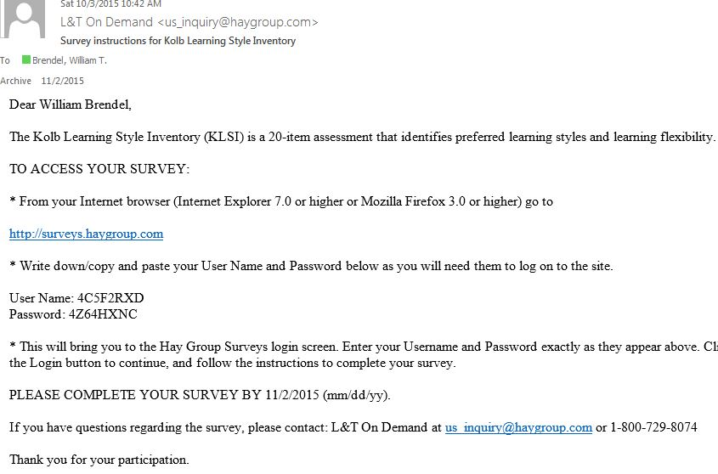

1. **Registration Complete (Receive Username/Password)**

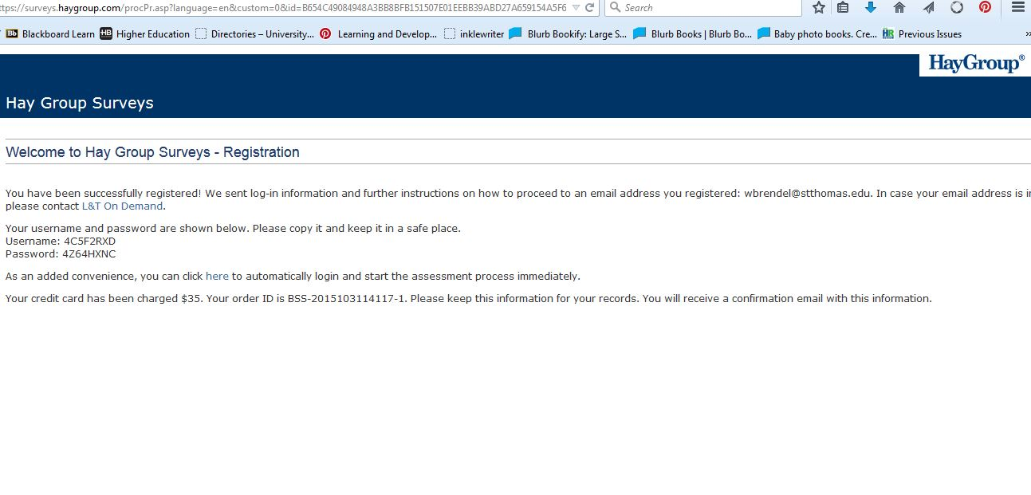

1. **Next Steps**

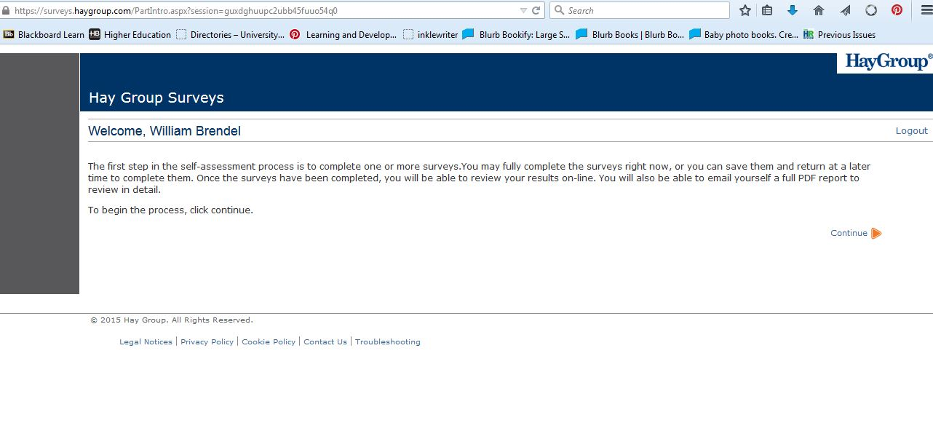

1. **Sent to Initial Dashboard (Addendum A for Code)**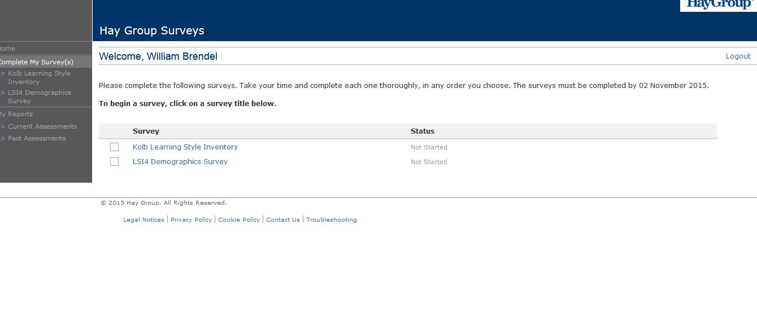
2. **Fill out Demographic Information** 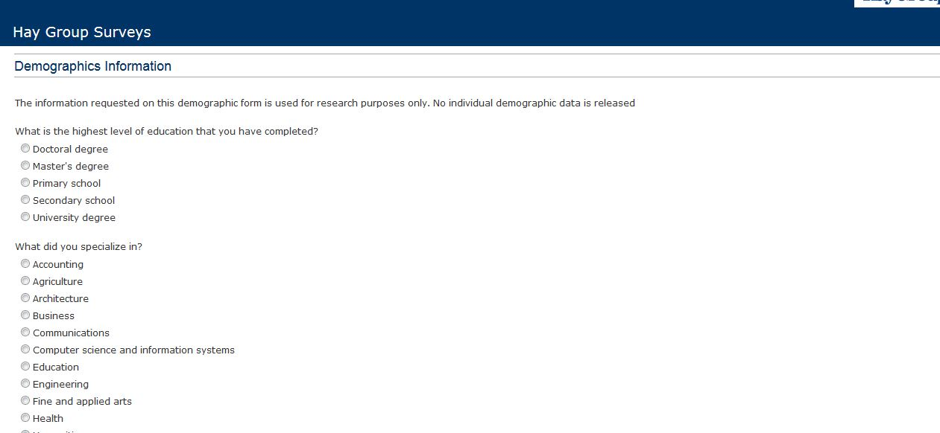
3. **LSI Instructions Page**

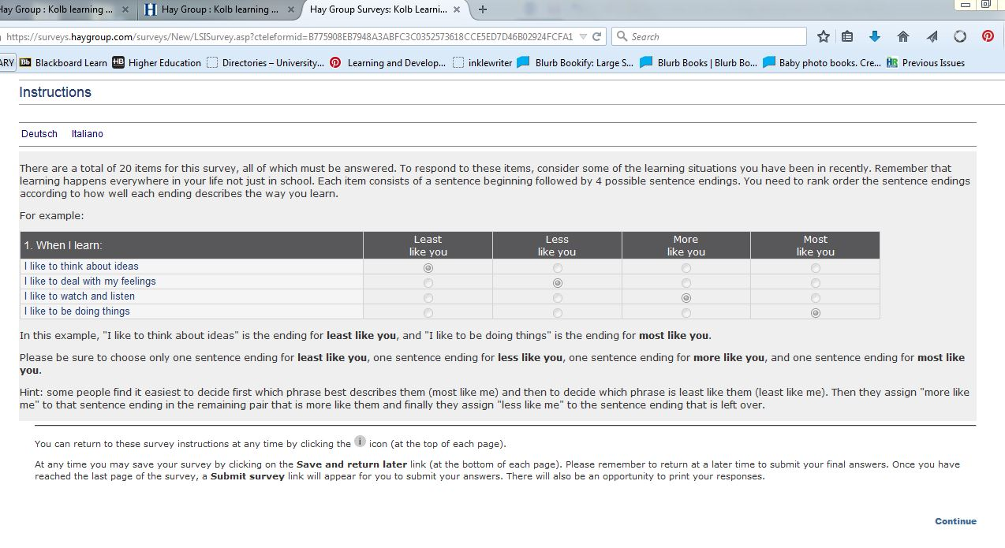

1. **Take the Survey (See Code in separate PDF)**
2. **Receive Survey Confirmation + Report Email (See PDF for the final report)**